

Md Farukul Islam
Carlos Martinez de la Riva Valdaliso
Albin Westerlund
IoT Ticket and Solar Power Plant
Project plan

Version history
Version | Change description | Person | Date

Returned: 20.9.19________________
Checked: _____________________
Approved: _____________________

Contents

1 INTRODUCTION 3
1.1 General Description of the Project 3
1.2 The Aim of the Project 3
1.3 Project Team 3
1.4 Right to the Deliverables of the Project 3
2 PHASES OF THE PROJECT 3
3 resource and time allocation plan 4
4 working methods and tools 5
4.1 Tools and Devices 5
4.2 Documentation Methods and Tools 5
4.3 Working Methods 5
4.4 Risk Management 5
4.5 Work Roles and Areas of Responsibility 6
4.6 Reference List 6
5 project control plan 6
5.1 Following the Status of the Project 6
5.2 Schedule 6

INTRODUCTION

General Description of the Project
Development of a remote monitoring service for a solar power plant on Technobotnia for our customer Timo Kankaanpää.

The Aim of the Project
The customer will be able to remotely monitor the electricity production at the solar power plant through an easy to use online dashboard. The dashboard will be online in IoT Ticket and contains necessary data and gauges. The data from the power plant will be delivered live or with minimal delay but there will also be historical information e.g. kWh produced during the past day.

Project Team
Role: Manager & Developer & Reporter
Name: Md Farukul Islam
Tel: -
E-mail: mfislam007@yahoo.com
https://omega.cc.puv.fi/redmine/projects/solar

Role: Developer & Reporter
Name: Carlos Martinez de la Riva Valdaliso
Tel: -
E-mail: c115875@student.uwasa.fi
https://omega.cc.puv.fi/redmine/projects/solar

Role: Developer & Reporter
Name: Albin Westerlund
Tel: -
E-mail: a111113@student.vamk.fi
https://omega.cc.puv.fi/redmine/projects/solar

Right to the Deliverables of the Project
The three project team members (Md Farukul Islam, Carlos Martinez de la Riva Valdaliso, Albin Westerlund) will hold all the rights for the developed system and each one owns one third (1/3).

PHASES OF THE PROJECT
The project is done using the scrum method and sprints. The project is divided into three sprints.
Each sprint contains 3-15 issues/tasks depending on the size of the project.
The project plan is made into Redmine, which can be found on https://omega.cc.puv.fi/redmine/projects/solar
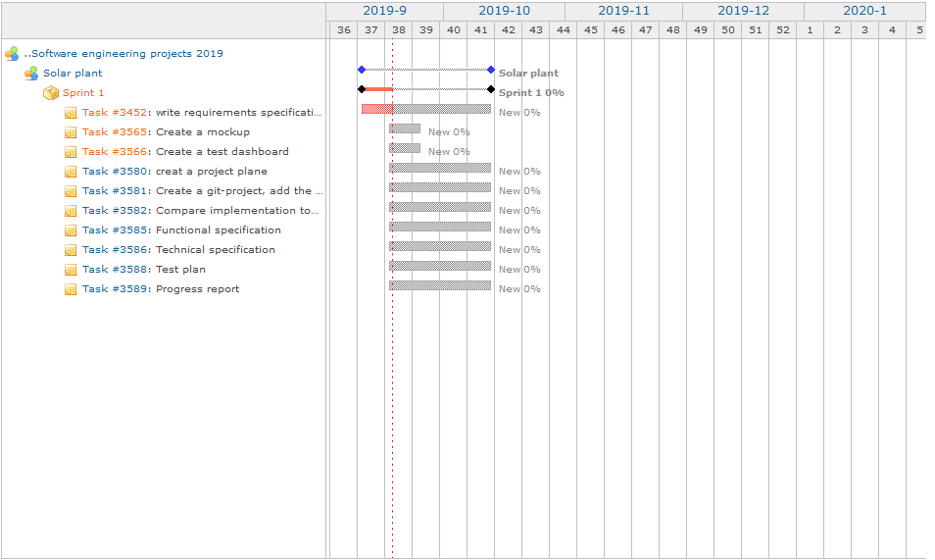
Table 1. Project schedule

resource and time allocation plan
The project resources are calculated for each person so that the workload is divided equally. The available allocated resource hours per people is calculated from the school timetable. Every student has two (2) double lectures. One lecture is one and a half hours (1,5h) so a double lecture is three hours (3h). Given this, each student is allocated a maximum of 6 six hours (6h) a week.

working methods and tools

Tools and Devices
Computers available at VAMK or private computers, Wapice’s IoT Ticket, solar power plant at Technobotnia.

Documentation Methods and Tools
The teacher of the course will deliver the documentation templates onto which the project members will fill in the correct documentation. The documentation will be quality controlled by the project members and if there is something wrong in the documentation, it will be corrected.

Working Methods
Weekly project team meetings during which we go through what has been done and what will be done.

Risk Management
Table 2. Risk analysis
Risk | Analysis | Action
Experience of persons making the estimation are weak | 2*2=4 | Create new estimates during project.
Major changes of requirements during project | 2*3=2.0 | Write down, priority and discuss with customer before project
Not enough time is allocated | 1*1=1 | Change time allocation during project
The technology stops working | 1*2=2 | Ask teacher how to solve
A particular part may take longer to finish than what is planned for it | 2*2=4 | Change the deadlines
The IoT Ticket dashboard does not work | 2*2=4 | Google for a solution or ask someone who knows what’s wrong
Project schedule is not kept | 1*3=3 | The most important parts are prioritised

Work Roles and Areas of Responsibility
Farukul’s area of responsibility is to manage the project, see that everything is working and assing project members to different tasks, help develop the product and document what he has done. Carlos’ area of responsibility is to develop the product and document what he has done. Albin’s area of responsibility is to develop and document.

Reference List
VACON-8000-Solar-NXV0010-NXV0100-Manual-DPD00426A-UK
WRM247+_DataSheet_2015

project control plan

Following the Status of the Project
The project members continuously check the quality of the deliverables and Redmine for deadlines.

Schedule
The project members will continuously review the product and demonstrate for the customer how it works.

